Evostra Group D– Website & Dashboard Documentation

1. Introduction
The Evastro Group – D Project is a job market analysis system that combines a Python-Flask based web application with an interactive Power BI dashboard. The website focuses on job exploration and filtering, while the dashboard provides analytical insights such as skill demand, job trends, and company-wise distribution.
This combined system helps students, freshers, and professionals understand real-world job market patterns using structured CSV-based job data.

2. Objectives of the Project
- Analyze job market data efficiently
- Provide a centralized job exploration platform
- Identify in-demand skills and job categories
- Visualize job trends using dashboards
- Help users make informed career decisions
- Demonstrate integration of web development and data visualization

3. Scope of the Project

3.1 Website Scope
- Job listing and exploration
- Search and filter functionality
- Salary and experience-based categorization
- Clean and professional UI

3.2 Dashboard Scope
- Job category-wise analysis
- Skills demand visualization
- Year-wise job distribution
- Company and country-wise insights

4. Technologies Used

Frontend
- HTML5
- CSS3
- Responsive Grid Layout
- Minimal JavaScript

Backend
- Python 3
- Flask Web Framework

Data & Visualization
- CSV Dataset (Job Data)
- Power BI Desktop

Development Tools
- Visual Studio Code
- Git & GitHub

5. System Architecture
The project follows a simple and scalable architecture:
CSV Dataset → Flask Backend → HTML Templates → Website UI
CSV Dataset → Power BI → Interactive Dashboard
This approach avoids database dependency while allowing future scalability.

6. Website Module Description

6.1 Home Page
- Welcome message
- Navigation menu (Home, Jobs, About)
- Clean grey and white theme

6.2 Job Exploration Page
- Dynamic job cards loaded from CSV
- Displays job title, company, location, salary, and experience
- Search functionality
- Filters based on:
  - Job title
  - Location
  - Category
  - Experience level
  - Salary range

6.3 Job Detail Page (Maintenance Mode)
- Placeholder page for job details
- Automatic redirection to job list
- Graceful handling of missing URLs

6.4 About Page
- Project description
- Team member details
- Contact information

7. Dataset Description
The job dataset used for both the website and dashboard is stored in CSV format and contains:
- Job ID
- Job Title
- Company Name
- Location (City, Country)
- Job Category
- Skills
- Experience Level
- Salary (Minimum & Maximum)
- Job Tags
- Optional URLs
Unused columns are safely ignored by the system.

8. Power BI Dashboard Description

8.1 Dashboard Overview
The Power BI dashboard provides interactive visual analysis of job market data using filters and charts. It enables users to explore trends and patterns that are not easily visible in raw data.

8.2 Job Category Filter
- Allows filtering by job categories such as:
  - Content Writing
  - Data Analysis
  - Data Science
  - Design
  - DevOps
  - Finance
  - Marketing
  - Product Management
- Helps focus analysis on specific domains

8.3 Total Jobs Indicator
- Displays total number of jobs based on selected filters
- Provides a quick snapshot of job availability

8.4 Skills Demand Analysis
- Bar chart representing most in-demand skills
- Highlights technologies like Python, R, React, DevOps tools, Ansible, and Jira
- Useful for understanding current market skill requirements

8.5 Year-wise Job Distribution
- Pie chart showing jobs posted across different years
- Helps analyze growth and trends over time

8.6 Company and Country-wise Analysis
- Bar chart showing jobs by company
- Color-coded by country or region
- Identifies top hiring companies and regions

8.7 Job Skills Overview Table
- Displays job category-wise skill counts
- Shows skills required per category
- Useful for academic and career analysis

9. Advantages of the Combined System
- Combines functional job exploration with analytical insights
- Easy to use and understand
- No database dependency initially
- Suitable for academic evaluation
- Scalable for future enhancements

10. Limitations
- Static CSV-based data
- No real-time updates
- No user authentication
- Manual data refresh required

11. Future Enhancements
- Database integration
- Automated data scraping
- User login and personalization
- AI-based job recommendations
- Predictive analytics dashboard

12. Conclusion
The Evastro Group – D Project successfully integrates a job exploration website with a Power BI dashboard to deliver both operational functionality and meaningful job market insights. The project demonstrates strong skills in Python, web development, and data visualization, making it suitable for both academic submission and real-world applications.

Screenshot of dashboard

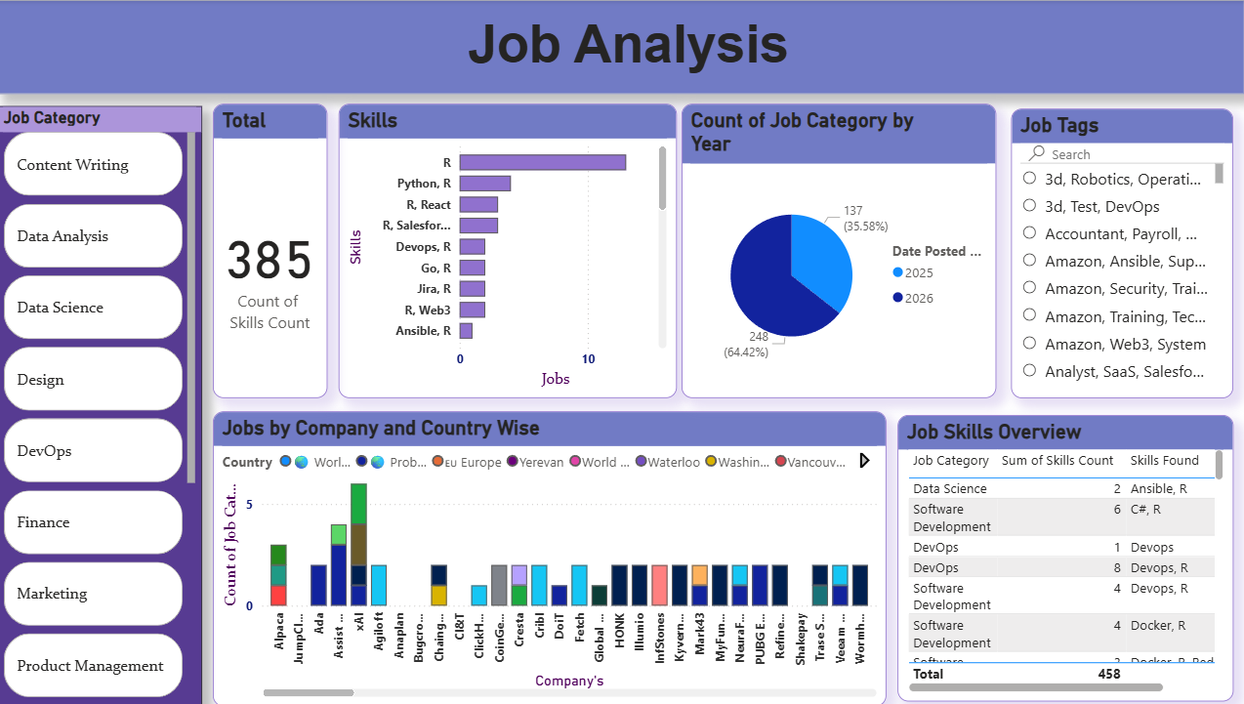

Screenshot of Website

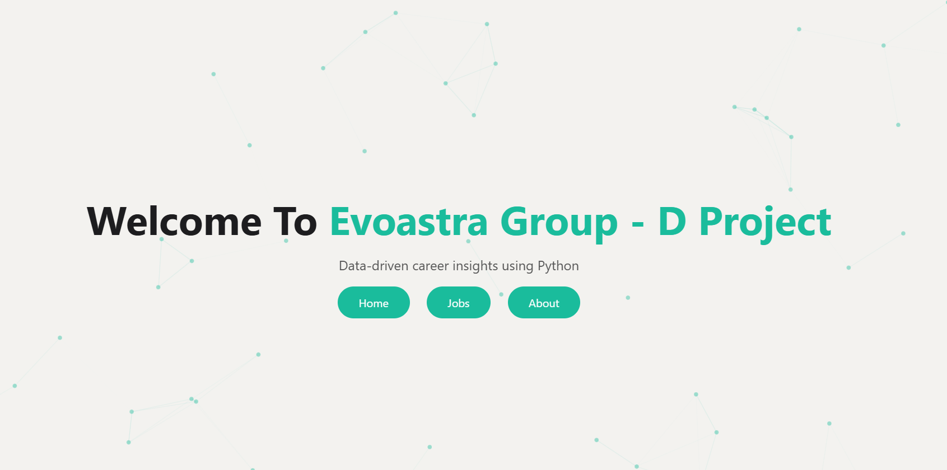

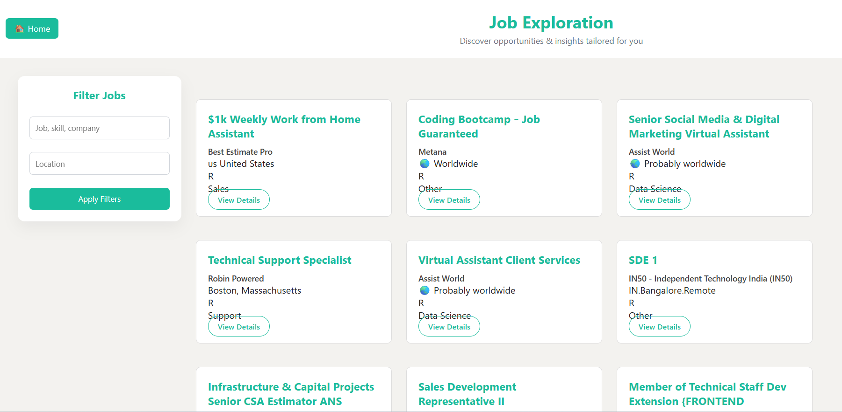

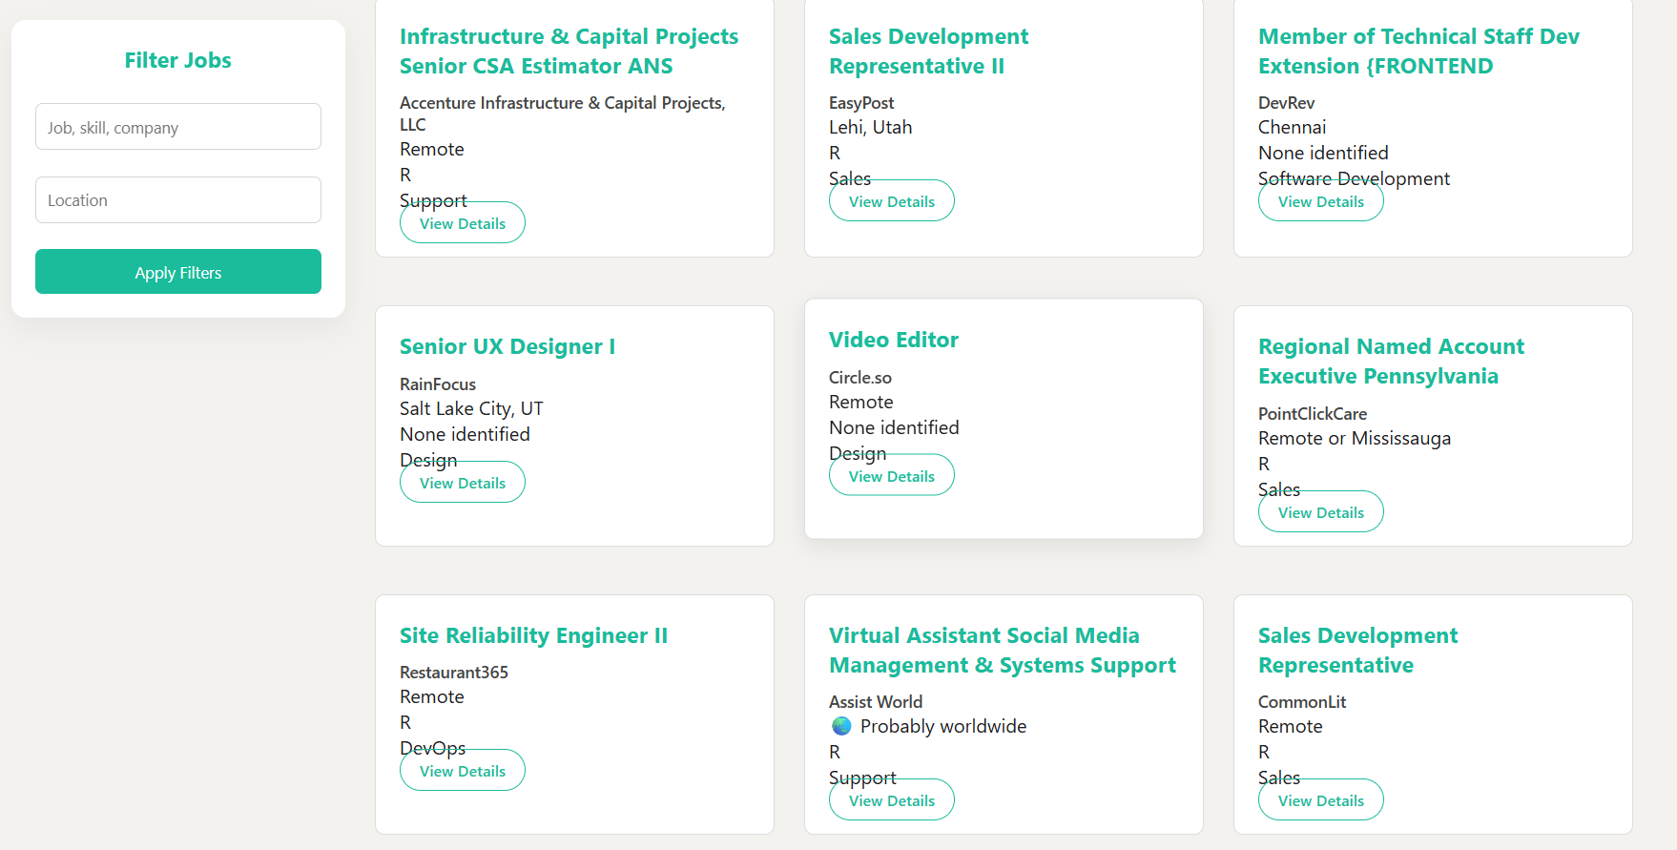

Participation Of team members

